Summary vs. Analysis
When asked to write an analysis, it is not enough to simply summarize. You must also add your own analysis of what you’ve discovered about your topic. Analysis means breaking something down into its various elements and then asking critical thinking questions such as WHY and HOW in order to reach some conclusions of your own. Let’s examine what it means to analyze and what it looks like.

What is analysis and how is this different than summary?
To summarize is to take ideas and present them again in a more concise way. But to analyze is to reach your own conclusions about how the elements of a topic, theory, issue, or story fit together to create something that may not be evident at first glance.
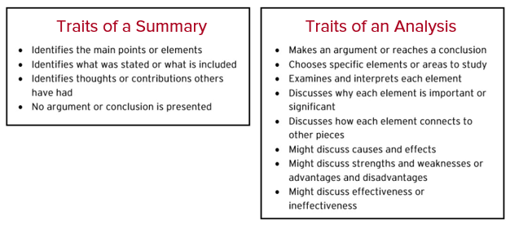

As you can see from the list of traits above, summary involves identifying, while analysis takes this a step further by discussing how and why pieces of a whole function together to create meaning and significance.

How does one do an analysis?
- Choose a Topic
Begin by choosing the elements or areas of your topic that you will analyze. You’ll need to break down the topic, theory, issue, or story that you are analyzing into its various pieces or parts.
  - For example, elements of a story may be the setting, the characters, or the conflict. Elements of a social issue may be the economic effects, the ethical perspective, or the people that are affected.
- Take Notes
Make some notes for each element you are examining by asking some WHY and HOW questions, and do some outside research that may help you to answer these questions.
  - For example: How does this element affect the other pieces? How do I understand this element and its function? Why is this element significant? Why is this element effective or ineffective? How and why does this element cause certain effects? How does this element contribute to the overall meaning?
- Draw Conclusions
Make some overall conclusions based on your questions and answers for each of the elements you have analyzed. Your conclusions will be your analysis that you write in your paper.

What does analysis look like compared to summary?
Example Summary of the Wright Brother’s Aeroplane Company Museum
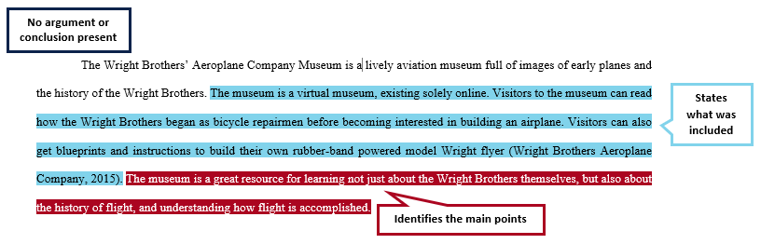
Example Analysis of the Wright Brother’s Aeroplane Company Museum
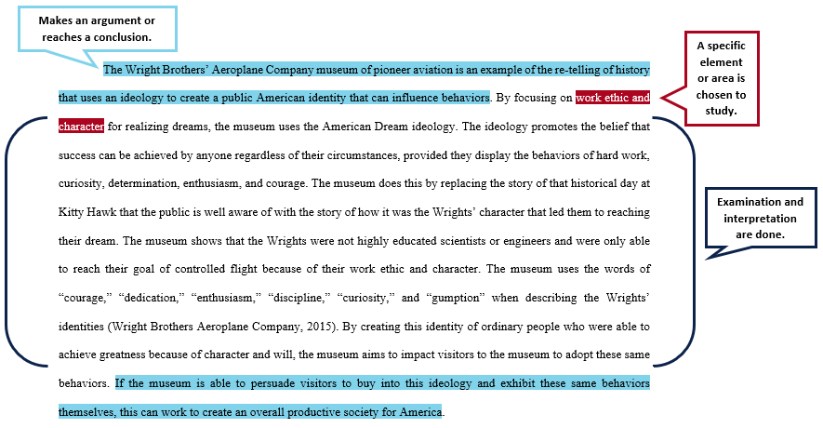

Care of - The University of Arizona, Global Campus, Writing Center
© 2021 Zovio

